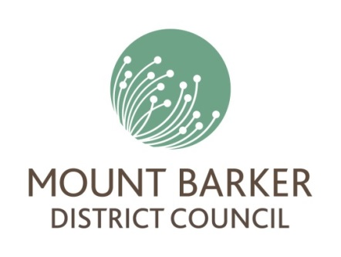
Mount Barker Irrigation Scheme

Registration of Interest
Version:1.0
Date: 04/06/2018

Declaration
I am authorised to submit this Registration of Interest for the Mount Barker Irrigation Scheme on behalf of the proponent.
I acknowledge that this Registration of Interest is solely for the purpose of advising SA Water and Mt Barker District Council of the proponent’s interest in water. It does not create any legal entitlement to water now or in the future, and it does not impose any obligation on SA Water or Mt Barker Council to offer water to the proponent.
Full Name
Position in Enterprise
Signature
Date

Privacy Statement
The Government of South Australia is committed to protecting the privacy of your information. In 1989, the Government of South Australia issued a set of Information Privacy Principles (reissued 30 July 1992 and 18 May 2009, 4 February 2013, 5 August 2013, 16 September 2013, and 20 June 2016) to regulate the way personal information can be collected, used, stored and disclosed.

Contact details

Business identity
Trading Name
Legal Entity Name
Australian Business Number (ABN)
Australian Company Number (ACN)

Physical address
Number and Street
Suburb or Town
State or Territory
Postcode

Postal address
Number and Street/PO Box
Suburb or Town
State, Territory, or Province
Postcode or ZIP
Country

Nominated contact
Title
First Name
Last Name
Position
Phone
Email

Business sector
Please state your industry sector e,g horticulture, mining, energy.

4. Water requirements

Proposed Water Use/Need

